# CSC430/530 – Database Management Systems

Assignment #4 – Functional Dependencies & Normalization

1. Consider following relation for published books:

# BOOK

FD1



FD3

FD2

Publisher

Author_affil

List_price

Book_type

Author_name

Book_title

* + *Author_affil* refers to the affiliation of the author.
  + Primary key is {*Book_title, Author_name*}.
  + Functional dependencies are:

FD1: *Book_title* -> *Publisher, Book_type*

FD2: *Book_type* -> *List_price*

FD3: *Author_name* -> *Author_affil*

1. What normal form this relation in (1NF, 2NF, 3NF)? Justify your answer by describing violations of normal forms (if any).

**This relation is in 1NF.**

**FD1 violates 2NF.**

**The non-prime attributes Book_type and Publisher are partially functionally dependent on Book_title.**

**FD3 violates 2NF.**

**Author_affil is partially functionally dependent on Author_name.**

**FD2 violates 3NF.**

**Transitive dependency formed by Book_title -> Book_type and Book_type -> List_price.**

1. Describe steps to normalize this relation up to 3NF. For full points, show all decomposed relations.

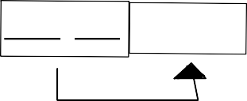

Author_name Author_aﬃl

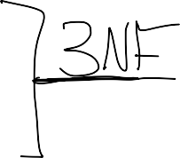

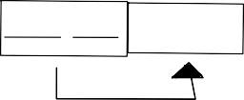

Author_name Author_aﬃl

Book_type List_price

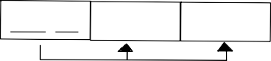

Book_title Publisher

Book_type

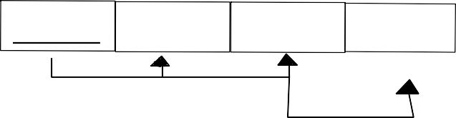

Book_title

Publisher

Book_type List_price

1. Define which of the provided functional dependencies may hold for the given relation. If the dependency does not hold, explain why by specifying tuples that cause the violation.
2. Text -> Course

|  |  |  |  |  |
| --- | --- | --- | --- | --- |
|  | **Instructor** | **Course** | **Text** | **Quarter** |
| 1 | Smith | Data Structures | Bartam | Spring |
| 2 | Hall | Systems Programming | White | Winter |
| 3 | Brown | Programming Languages | Williams | Summer |
| 4 | Smith | Data Structures | Bartam | Winter |
| 5 | Ross | Data Mining | Williams | Summer |
| 6 | Hall | Systems Programming | White | Spring |
| 7 | Johnson | Databases | Elmasri | Fall |

1. Text -> Instructor
2. Instructor -> Course
3. Course -> Text
4. Course -> Quarter
5. **Doesn't hold. (Williams -> Programming Languages and Williams -> Data Mining) 3 & 5 violate it.**
6. **Doesn't hold. (Williams -> Brown and Williams -> Ross) 3 & 5 violate it.**
7. **Holds.**
8. **Holds.**
9. **Doesn't hold. (Data Structures -> Spring and Data Structures -> Winter) 1 & 4 violate it.**